**Android Game Suite**

**CS 430**

**Software Design Specification**

**March 7th, 2010**

Benjamin Carpenter

Ryan Daugherty

Jack Dehlin

*Jay Greene*

Table of Contents

1.0 Introduction 4

1.1 Goals and objectives 4

1.2 Statement of scope 4

1.4 Major constraints 4

2.0 Data design 4

2.1 Internal software data structure 4

2.2 Global data structure 5

2.3 Temporary data structure 5

3.0 Architectural design 5

3.1 Program Structure 5

3.1.1 Architecture diagram 5

4.0 Schedule 6

4.1 Scheduling diagram 6

4.2 Definition of milestones 6

4.2.1 Concept/Doc Complete 3/5/2010 6

4.2.2 Module Code Complete 4/8/2010 7

4.2.3 Testing Complete 4/19/2010 7

5.0 Component-level design 7

5.1 Description for Main Menu 7

5.1.1 Processing narrative for Main Menu 7

5.1.2 Main Menu interface description 7

5.1.3 Main Menu processing detail 7

5.1.3.1 Performance issues 7

3.2.3.2 Design constraints 8

5.2 Description for Individual Games 8

5.2.1 Processing narrative for Individual Games 8

5.2.2 Individual Game interface description. 8

5.2.3 Individual Game processing detail 8

5.2.3.1 Performance issues 8

5.2.3.2 Design constraints 8

6.0 User interface design 8

6.1 Description of the user interface 9

6.1.1 Home Screen 9

6.1.1.1 Screen Shot for Home Screen 9

6.1.1.2 Objects and actions for Home Screen 10

6.1.2 Word Search Main Screen 10

6.1.2.1 Screen Shot for Word Search Main Screen 10

6.1.2.2 Objects and actions for Word Search Main Screen 10

6.1.3 Word Search In Game 11

6.1.3.1 Screen Shot for Word Search In Game 11

6.1.3.2 Objects and actions for Word Search In Game 12

6.1.4 Battle Ship Main Screen 12

6.1.4.1 Screen Shot for Battle Ship Main Screen 12

6.1.4.2 Objects and actions for Battle Ship Main Screen 12

6.1.5 Battle Ship In Game 13

6.1.5.1 Screen Shot for Battle Ship In Game 13

6.1.5.2 Objects and actions for Battle Ship In Game 13

6.1.6 Connect 4 Main Screen 14

6.1.6.1 Screen Shot for Connect 4 Main Screen 14

6.1.6.2 Objects and actions for Connect 4 Main Screen 14

6.1.7 Connect 4 In Game 15

6.1.7.1 Screen Shot for Connect 4 In Game 15

6.1.7.2 Objects and actions for Connect 4 In Game 15

6.1.8 Word Guesser Main Screen 16

6.1.8.1 Screen Shot for Word Guesser Main Screen 16

6.1.8.2 Objects and actions for Word Guesser Main Screen 16

6.1.8 Word Guesser In Game 16

6.1.8.1 Screen Shot for Word Guesser In Game 16

6.1.8.2 Objects and actions for Word Guesser In Game 17

6.1.9 Sudoku Main Screen 18

6.1.9.1 Screen Shot for Sudoku Main Screen 18

6.1.9.2 Objects and actions for Sudoku Main Screen 18

6.1.10 Sudoku In Game 19

6.1.10.1 Screen Shot for Sudoku In Game 19

6.1.10.2 Objects and actions for Sudoku In Game 19

6.2 Interface design rules 20

7.0 Restrictions, limitations, and constraints 20

8.0 Testing Issues 20

8.1 Classes of tests 20

8.2 Expected software response 20

9.0 Appendices 20

9.1 Packaging and installation issues 20

9.2 Legal Considerations 21

# 1.0 Introduction

This document specifies the requirements for the production and design of the Game Suite software for the Google Android operating system. The product will be a suite of five simple and easy games for a user to play. The games include a word search, connect four, battle ship, hangman, and a Sudoku. The first four games will be uniquely developed and the fifth will use an open source Sudoku. The user interface will be easy to use and allow the user to go in-between games with ease. The android operating system uses a market place to sell applications for the phone.

## 1.1 Goals and objectives

The goal of this project is to produce an interactive and entertaining application for the Android marketplace. This application will be a suite of several smaller games, one of which is open source, the rest custom made.They will be playable on any phone supporting the android operating system with access to the Internet.

## 1.2 Statement of scope

The only input to this project is the user's attention and strategic moves; and the only output is the entertainment that is a consequence of the input.1.3 Software context

The big picture of this project will be to provide entertainment for anyone with access to an Android device.

## 1.4 Major constraints

Since this project can easily be broken down into many smaller functioning parts, there are few major constraints. As long as the Android Marketplace is up and running and people are still using the Android OS, it will be possible to market, maintain, and operate this application.

# 2.0 Data design

## 2.1 Internal software data structure

The data for each of the five games will mostly be kept separate from the other games in the system as well as from the main menu. Each game will use the methods most appropriate for storing their data. All data will be stored either in variables particular to each game or as files on the Android based phones memory card.

## 2.2 Global data structure

The system will be very modularized with each game creating and storing data independently of each other and the overall system. Each game will store its own data relating to high scores, game state, preferences, etc. All of this persistent data will be stored on the Android phones memory card as either flat files or within a database individual to each game.

## 2.3 Temporary data structure

Each game will also need to store temporary information such as current score, user selections, player’s turn, etc. While this information will be stored temporarily as variables during game play they should be saved to the Android phones memory card in that case that the user exits during the middle of a game.

# 3.0 Architectural design

## 3.1 Program Structure

The android game suite will utilize a call-and-return architecture since the program operates through a sequence of hierarchical menus. At the bottom of the hierarchical tree the program will return dynamic responses to the users strategic menu choices.

### 3.1.1 Architecture diagram

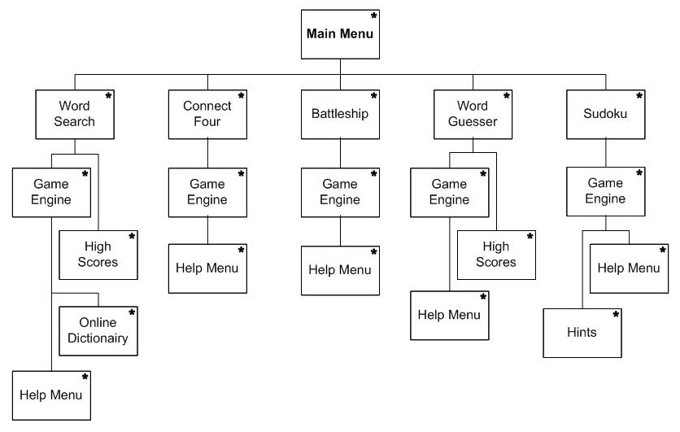

# 4.0 Schedule

This program development will undergo three major cycles. The first cycle is the Documentation Phase where the Requirements and Software Design documents are built. These documents will provide the group with the layout for each module and diagrams on how everything works together. The second cycle will be the actual coding of each module (and sub-programs). This pertains to members completing their assigned sub-game. This includes their individual sub-menu, module design, and module testing. By the end of this cycle they are expect to have a stand-alone working mini-game ready for system integration. The third and final cycle entails overall system testing and integration. During this phase all mini-games and sub-menus are integrated and tested. If time permits, interface improvements and documentation updates may be preformed during this time.

## 4.1 Scheduling diagram

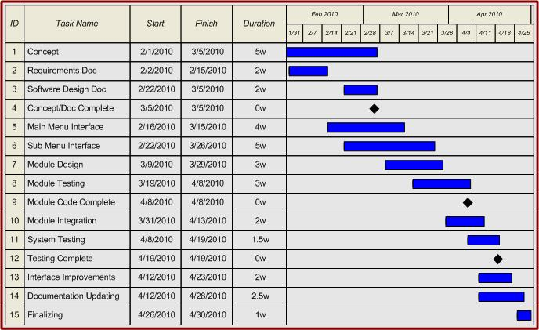

## 4.2 Definition of milestones

### 4.2.1 Concept/Doc Complete 3/5/2010

All concept related documentation such as module definitions, data flow diagrams, user diagrams, etc will be completed by this date. The Requirements Documentation and System Design Documentation will be completed by this date such that module design and coding may begin.

### 4.2.2 Module Code Complete 4/8/2010

All module coding should be completed by this date so that module integration and system testing begin. Depending on Integration complexity, integration may begin 1 week before this milestone. All modules and sub-programs are expected to be fully functional and extensively tested.

### 4.2.3 Testing Complete 4/19/2010

All testing should be finished by this date and the program should be essentially complete. The remaining time may be used for small UI tweaking and documentation updates.

# 5.0 Component-level design

Our system is based around a main menu through which each of the individual games can be accessed. At any time the user can exit a game, which will return them to the main menu.

## 5.1 Description for Main Menu

The main menu is the first thing a user will see when launching the application on their Android based phone.

### 5.1.1 Processing narrative for Main Menu

From the main menu the user can select one of five games or choose to exit the application. Upon selecting a game the particular activity for that game will be launched. If the user chooses to exit the application will be closed and the user returned to the Android operating system interface.

### 5.1.2 Main Menu interface description

The main menu will consist of a simple list of buttons corresponding to the individual games as well as a button for choosing to exit the application.

### 5.1.3 Main Menu processing detail

### 5.1.3.1 Performance issues

The main menu will use relatively little resources, as it will just be a list of buttons.

### 3.2.3.2 Design constraints

The main menu should be simple and easy to use for accessing the individual games.

## 5.2 Description for Individual Games

The individual game components will be launched from the main menu and will run independently of each other.

### 5.2.1 Processing narrative for Individual Games

When each game is launched the user will be presented with a choice such as selecting words from a word search or selecting a column to place a chip for connect four. The users’ choices will result in the score being increased or a chip being placed in the game board for example. This process of the user making selections and the results being processed will continue until the game is completed, either successfully or otherwise, or the user chooses to exit or restart the game. The user will also have the option to restart the game, which will result in the process restarting from the beginning.

### 5.2.2 Individual Game interface description.

Each game will have buttons on the screen, which the user can press in order to, play the game. In the case of the connect four game the user will be able to press one of seven buttons at the top of a game board to select which column to place their chip in. There will also be a menu button for each game, which will give more options such as exit or restart.

### 5.2.3 Individual Game processing detail

### 5.2.3.1 Performance issues

Each of the games should respond quickly to users input through the buttons on the screen. Delayed responses could frustrate the user or lead to believe that the application is frozen.

### 5.2.3.2 Design constraints

The design of the interfaces for the games should be simple and intuitive so that the user can easily identify what options they currently have to progress the game.

# 6.0 User interface design

Below are prototype designs of each games interface.

## 6.1 Description of the user interface

Screen shots from each game are show using the Software Development Kit through Eclipse.

### 6.1.1 Home Screen

### 6.1.1.1 Screen Shot for Home Screen

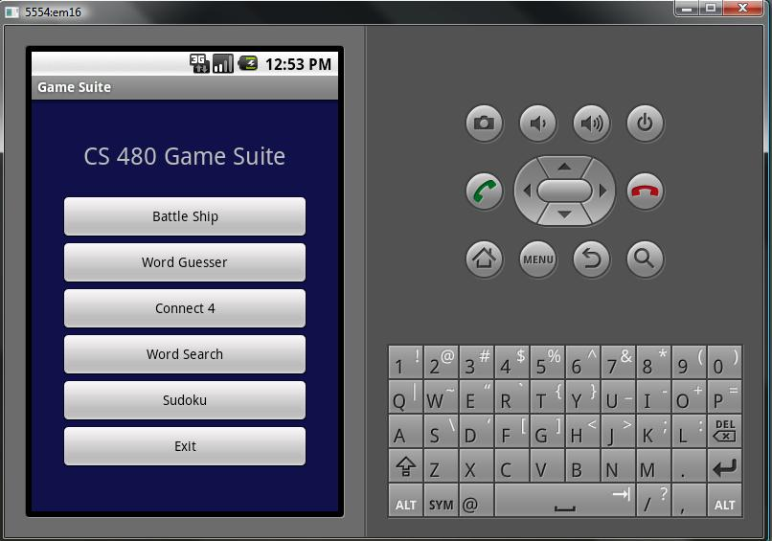

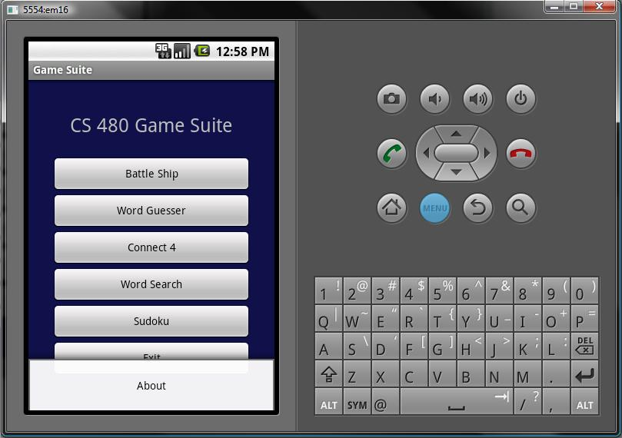

### 6.1.1.2 Objects and actions for Home Screen

Objects:

* Battle Ship
* Word Guesser
* Connect 4
* Word Search
* Sudoku
* Exit
* About

Actions:

* Go to Battle Ship Main Screen
* Go to Word Guesser Main Screen
* Go to Connect 4 Main Screen
* Go to Word Search Main Screen
* Go to Sudoku Main Screen
* Exits the application
* Shows the members of the group

### 6.1.2 Word Search Main Screen

### 6.1.2.1 Screen Shot for Word Search Main Screen

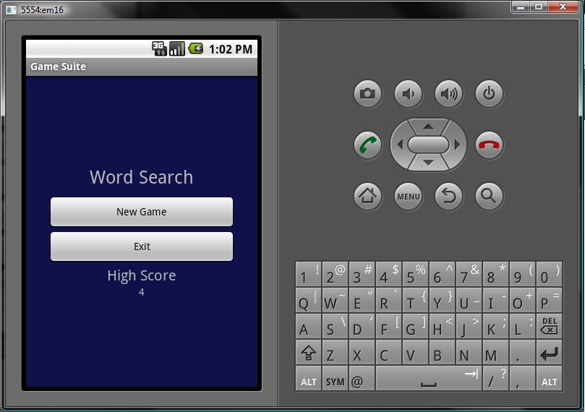

### 6.1.2.2 Objects and actions for Word Search Main Screen

Objects:

* New Game
* Exit
* High Score

Actions:

* Start a new game
* Exit the to the Home Screen

### 6.1.3 Word Search In Game

### 6.1.3.1 Screen Shot for Word Search In Game

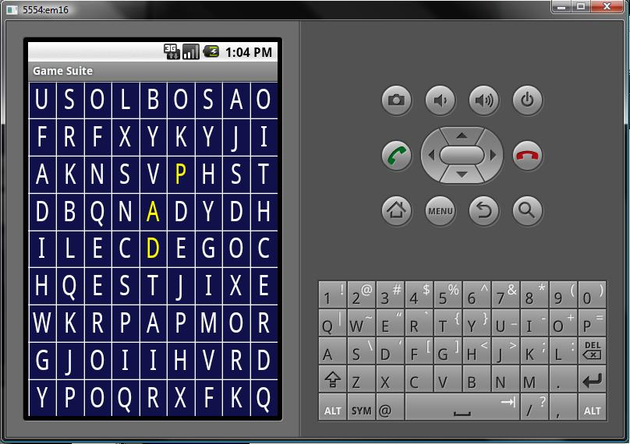

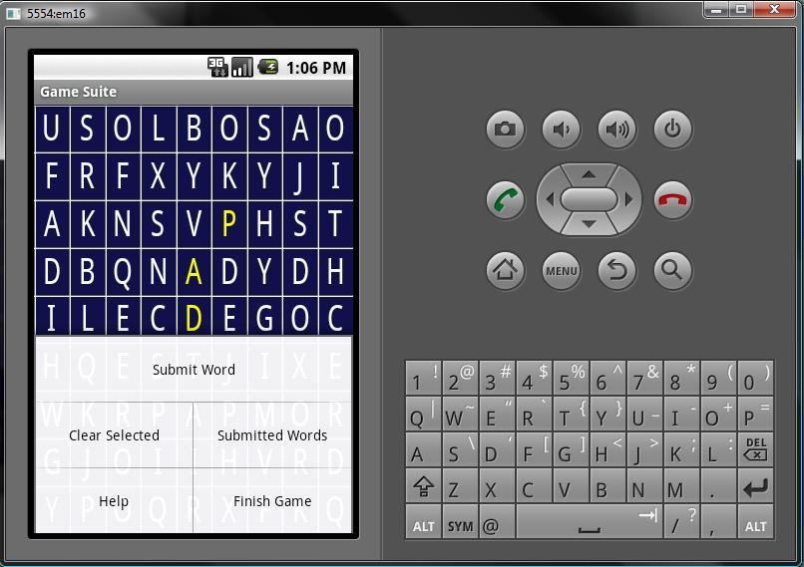

### 6.1.3.2 Objects and actions for Word Search In Game

Objects:

* Letter 9 x 9 grid
* Submit Word
* Clear Selected
* Submitted Words
* Help
* Finish Game

Actions:

* Select Letters
* Submit a word to be checked against a dictionary
* Clear the currently selected letters
* View the already submitted words
* Show the help screen
* Finish the game
* Show the score

### 6.1.4 Battle Ship Main Screen

### 6.1.4.1 Screen Shot for Battle Ship Main Screen

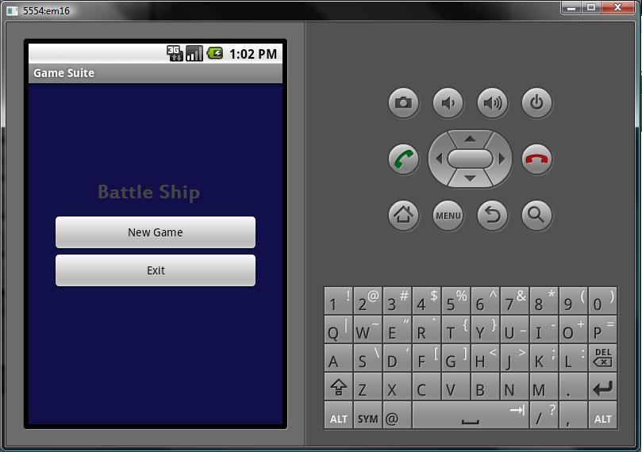

### 6.1.4.2 Objects and actions for Battle Ship Main Screen

Objects:

* New Game
* Exit

Actions:

* Starts a new game
* Exits back to the Home Screen

### 6.1.5 Battle Ship In Game

### 6.1.5.1 Screen Shot for Battle Ship In Game

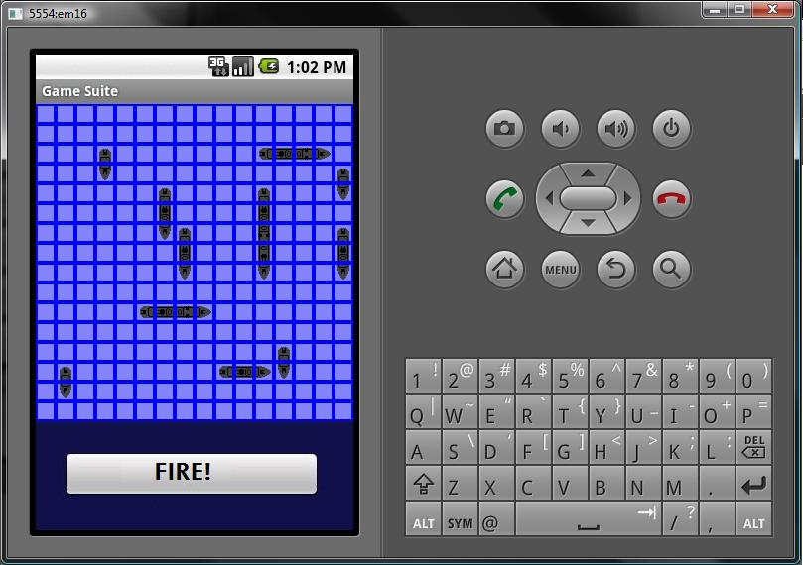

### 6.1.5.2 Objects and actions for Battle Ship In Game

Objects:

* 16 x 16 board
* 12 playable ships
* Fire button
* Ready button
* Help button

Actions:

* Place ships before any moves
* Ready to start game
* Select tile to fire on
* Fire on tile
* Send back hit or miss
* Shows help

### 6.1.6 Connect 4 Main Screen

### 6.1.6.1 Screen Shot for Connect 4 Main Screen

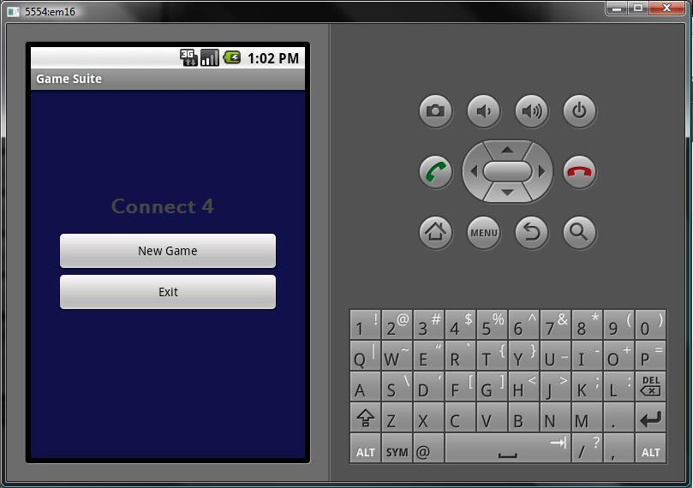

### 6.1.6.2 Objects and actions for Connect 4 Main Screen

Objects:

* New Game
* Exit

Actions:

* Starts a new game
* Exits back to the Home Screen

### 6.1.7 Connect 4 In Game

### 6.1.7.1 Screen Shot for Connect 4 In Game

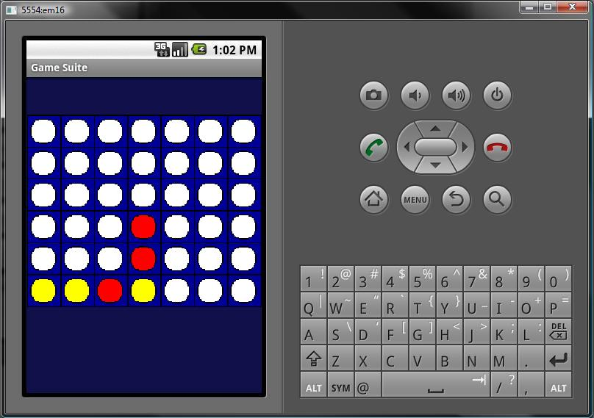

### 6.1.7.2 Objects and actions for Connect 4 In Game

Objects:

* 6 x 7 grid
* Help button

Actions:

* Select column to place chip
* Show help
* Display winner

### 6.1.8 Word Guesser Main Screen

### 6.1.8.1 Screen Shot for Word Guesser Main Screen

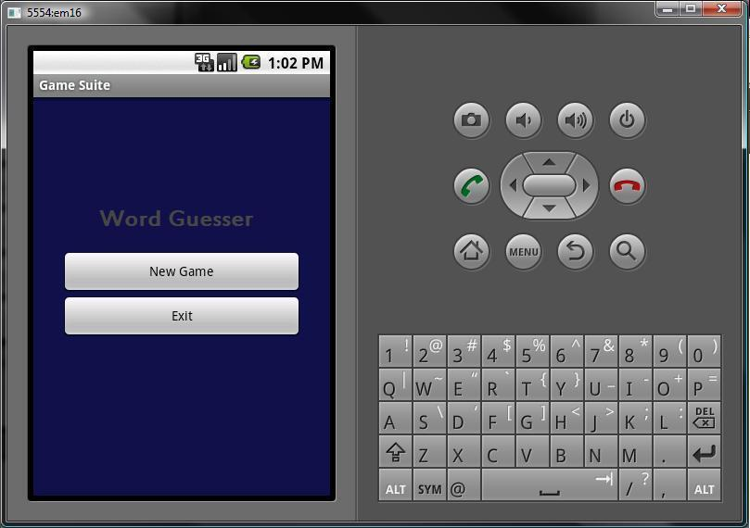

### 6.1.8.2 Objects and actions for Word Guesser Main Screen

Objects:

* New Game
* Exit

Actions:

* Starts a new game
* Exits back to the Home Screen

### 6.1.8 Word Guesser In Game

### 6.1.8.1 Screen Shot for Word Guesser In Game

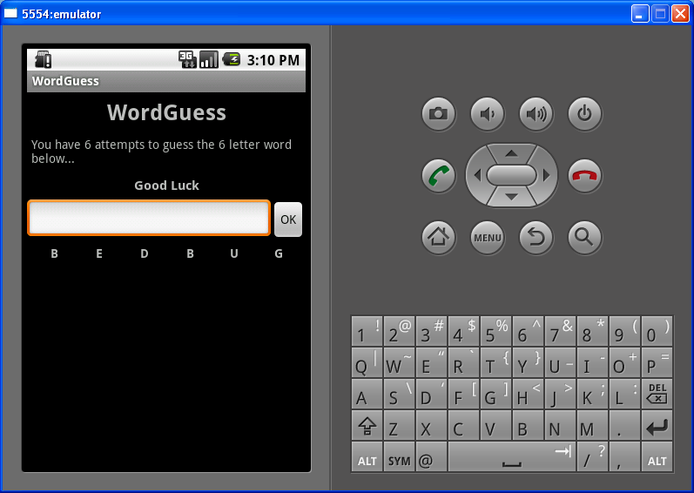

### 6.1.8.2 Objects and actions for Word Guesser In Game

Objects:

* Box for word
* Ok
* New Game (in menu)
* High Score (in menu)
* Help (in menu)
* Finish (in menus)

Actions:

* Enter letters to make word
* Submit word to be checked
* Start a new game
* View high score
* Show help screen
* Finish game

### 6.1.9 Sudoku Main Screen

### 6.1.9.1 Screen Shot for Sudoku Main Screen

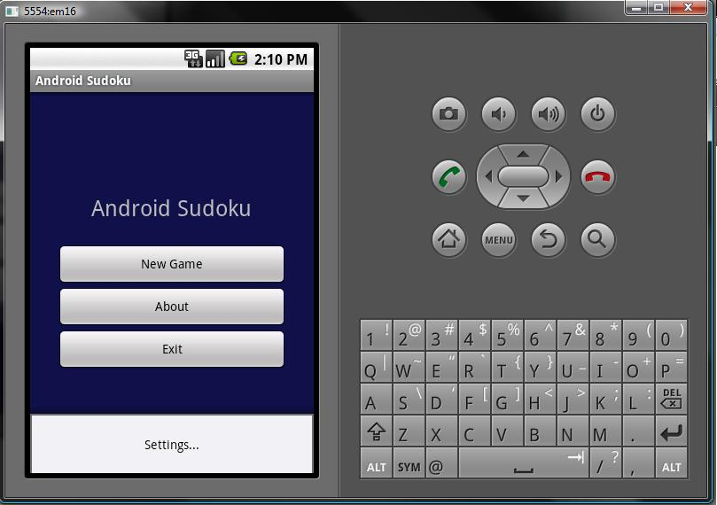

### 6.1.9.2 Objects and actions for Sudoku Main Screen

Objects:

* New Game
* About
* Exit
* Settings

Actions:

* Start a new game
* View the about page
* Exit to the Home Screen
* Set setting for music and hints

### 6.1.10 Sudoku In Game

### 6.1.10.1 Screen Shot for Sudoku In Game

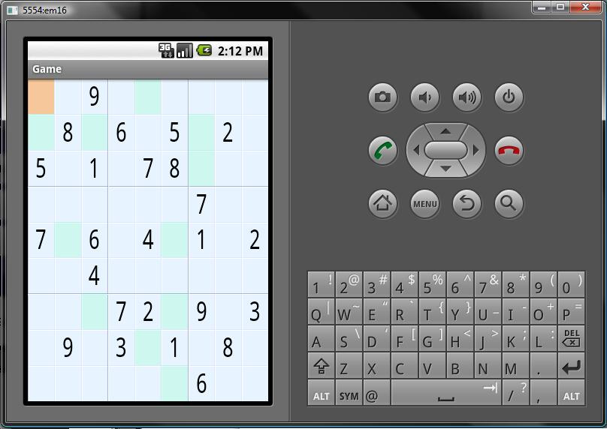

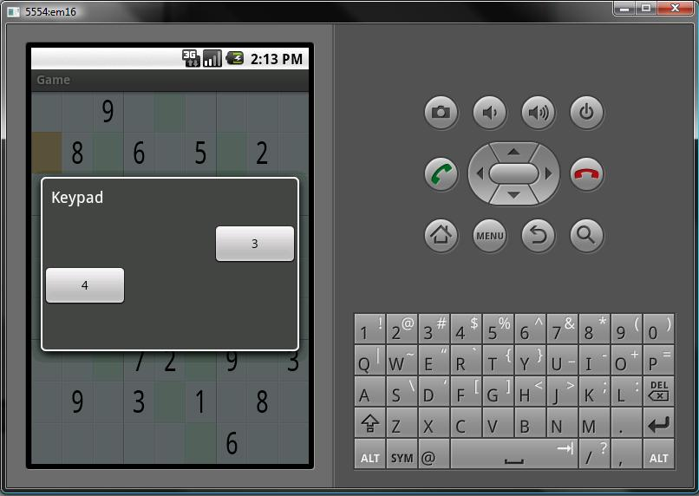

### 6.1.10.2 Objects and actions for Sudoku In Game

Objects:

* Difficulty select
* 9 x 9 grid with numbers
* Number choice to fill into tile

Actions:

* Select easy, medium, hard board
* Select tile
* Select number to fill into tile
* Show hints

## 6.2 Interface design rules

The interface will be designed under the rules of Java, Android, and XML. These rules help define what can be done for the interface.

# 7.0 Restrictions, limitations, and constraints

In order for the Game Suite application to be downloaded and installed for game play the user must be using a mobile device running Google’s Android Operating System version 1.5 and above, as well as having access to the Android Marketplace. All development for the Game Suite was done in the Eclipse Integrated Development Environment (IDE) on Windows XP and Vista machines with the Android Software Development Kit (SDK). Testing of the application was done on the Android Emulator that was included with the Android SDK. As long as the Android Marketplace is available to Google’s Android mobile Operating System users, the software will be marketable, maintainable and functional to both users and developers.

# 8.0 Testing Issues

## 8.1 Classes of tests

We will conduct first tests on each individual game within the Game Suite as separate entities using the Android Emulator supplied by the Android Software Development Kit (SDK). Once each individual game is tested thoroughly, the package will the built together and tested as a whole. All known valid input will be tested as well as known invalid input. A more comprehensive overview of our testing strategies will be included in our testing specification documentation.

## 8.2 Expected software response

Each test performed will be clearly observed as either failing or succeeding.

# 9.0 Appendices

## 9.1 Packaging and installation issues

The Software will be packaged and distributed as an applications installation package in the Android Marketplace. It will be available to all users of mobile devices running the Android Operating System version 1.5 and above.

## 9.2 Legal Considerations

We will be using the Android Software Development Kit (SDK) in accordance to the Android SDK License Agreement distributed by Google (Copyright holder of the Android SDK). This agreement grants us as developers “limited, worldwide, royalty-free, non-assignable, and nonexclusive rights to use the SDK solely to develop applications for the Android platform.”